# Cover



E-Library

An Online Library Management System

   

# Table of Contents

# Acknowledgement

We would like to express our heartfelt gratitude to the individuals and organizations who played a crucial role in the successful completion of this project. Each team member's dedication and collaborative spirit have contributed to the project's overall success.

Our gratitude goes to Mr. Ashish Jha for his guidance, support, and mentorship. His expertise and encouragement have been instrumental in steering the team in the right direction.

We are also thankful to Aptech Qatar for providing the necessary resources, facilities, and a conducive environment for teamwork and project development.

We express our thanks to the authors and researchers whose work served as a foundation for our understanding of Web Application Development

Finally, we extend our thanks to anyone else who has supported the team in various ways. Your collective efforts have made a significant impact on the project's success.

Thank you all for your dedication, hard work, and collaborative spirit. This project would not have been possible without each and every one of you.

# Project Synopsis

The E-Library project aims to streamline library management through an Online Library Management System. The system automates maintenance of book information, author details, member records, and library staff. This computerized solution reduces manual workload for librarians, ensuring efficient maintenance and preventing data loss. The system encompasses modules for Guest Users to view available titles, Register Users to access features like online reading and downloads, and an Admin module for comprehensive management. Admin capabilities include overseeing book details, user registration, categories, and generating reports. With simplified access and robust features, E-Library enhances library management, providing a user-friendly experience for both administrators and library members.

# Project Analysis

The online library management system is designed to streamline and automate various operations related to book management, user registration, and administrative tasks. The manual complexities of managing a library are addressed through computerization, reducing the workload and enhancing overall efficiency.

## Objectives

* Automate book management, user registration, and library operations.
* Reduce manual workload for librarians.
* Ensure accuracy and security of book and user records.
* Provide convenient access to information for both guests and registered users.
* Enable online reading and downloading of books (if permitted by admin).
* Facilitate efficient management through an admin dashboard.

## System Modules

### Guest Users

* View available book titles.
* Make inquiries through the contact us page.
* Access general information about the library, including timings and book categories.

### Registered Users

* One-time registration for E-Library access.
* Login to access various features.
* Search for books based on different criteria.
* Read books online.
* Download books (if permitted by admin).
* Access video tutorials under different categories.
* Change their passwords for security.

### Administrator

* Superuser with comprehensive control over the system.
* Dashboard for an overview of books, registered users, and categories.
* Manage categories: Create, update and delete.
* Manage books and videos: Add, edit, and set download permissions.
* Manage users: update and delete

## Key Features

* Efficiency: Automation reduces manual work for librarians, making library management more efficient.
* Accuracy: Computerization ensures accurate maintenance of book and user records.
* Convenience: Users can access and manage library resources online, improving convenience.
* Security: User data and book records are secure and less prone to loss.
* User Engagement: Features like online reading, downloads, and video tutorials enhance user engagement.

## Challenges and Considerations

* Ensure data security and privacy.
* Implement effective search functionality for users.
* Regularly update and maintain the system for optimal performance.
* Provide adequate documentation and user support.
* Test the system thoroughly to identify and address any bugs or issues.

## Conclusion

E-Library aims to modernize and simplify library operations, benefiting both librarians and users. By incorporating user-friendly interfaces and robust administrative features, the system is poised to enhance the overall library experience in the digital age. Regular updates and user feedback will be essential to ensuring the ongoing success and relevance of the system.

# Application Design

# User Guide

You can view the website online by going to:

|  |  |
| --- | --- |
|  | <https://elibrary.almir.info/> |

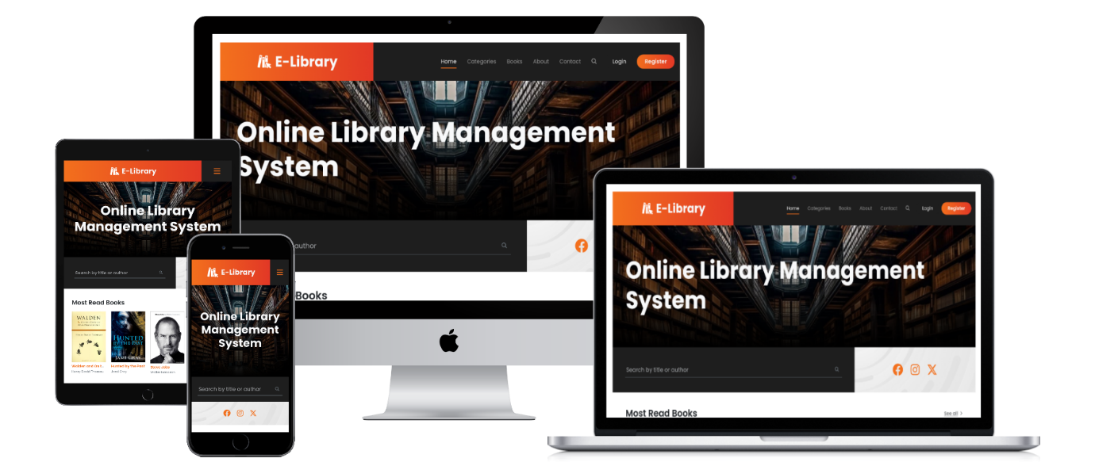

## Register

If this is first time visiting the website and you want to create an account, go to the register page by clicking on the Register button

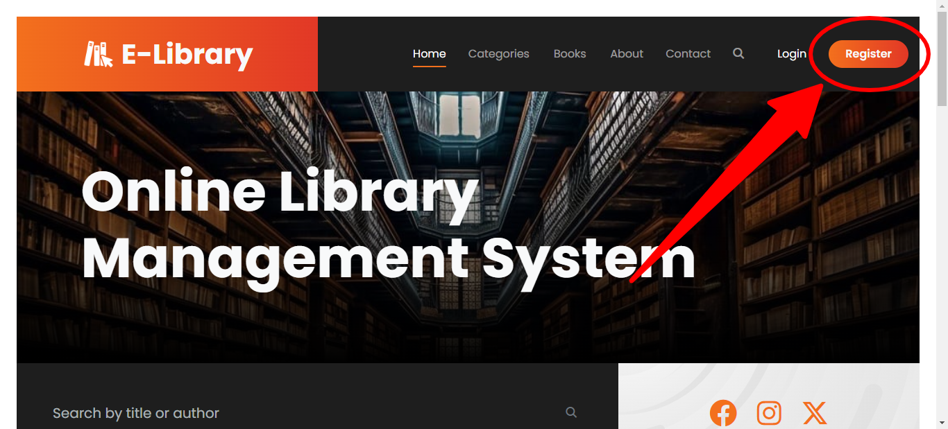

Fill in the details and click on the register to create a new account.

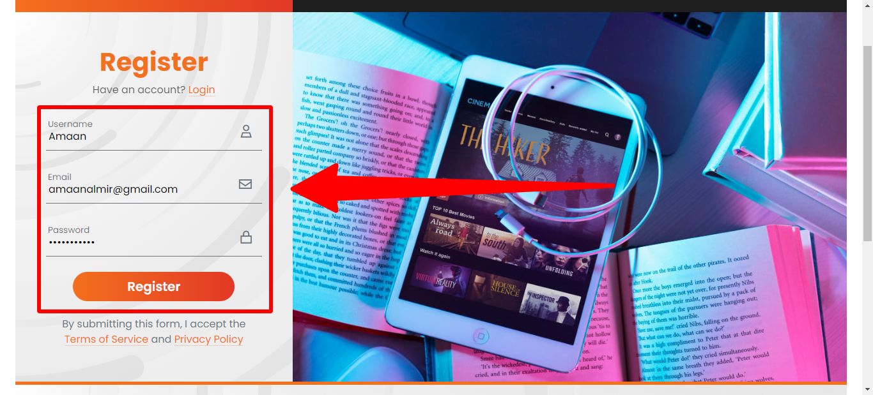

You may receive notifications if an error occurred while creating a new account.

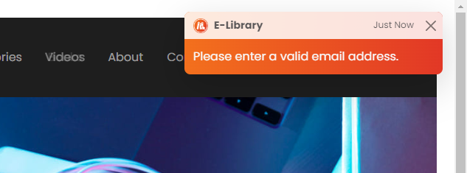

After successfully creating an account, you will receive an email to verify your email address. Check your mail to inbox and open the verification link to verify your email.

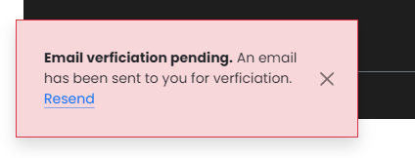

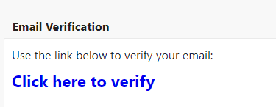

Upon clicking the verification link, your email address will be verified.

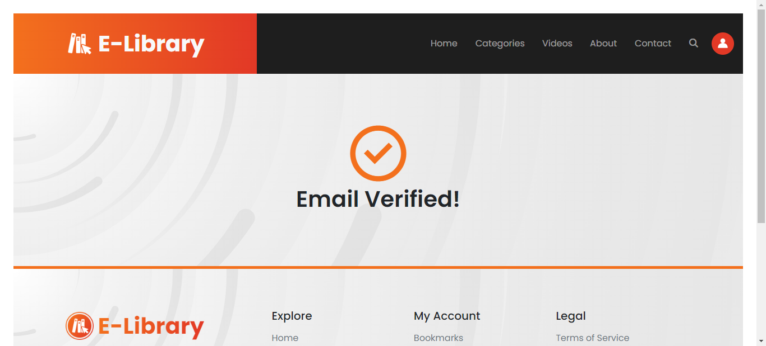

## Login

If you’re a returning user, you can use the login page to get into the website. Enter your email and p

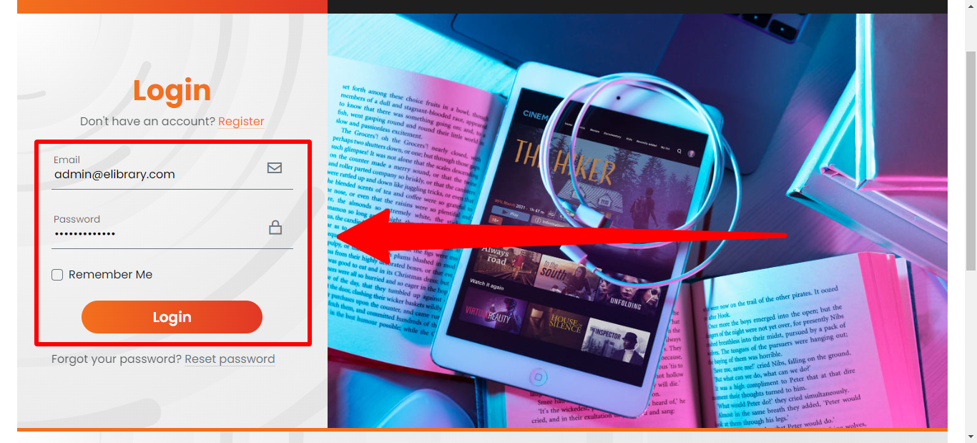

## Home page

The home page displays some trending books and videos.

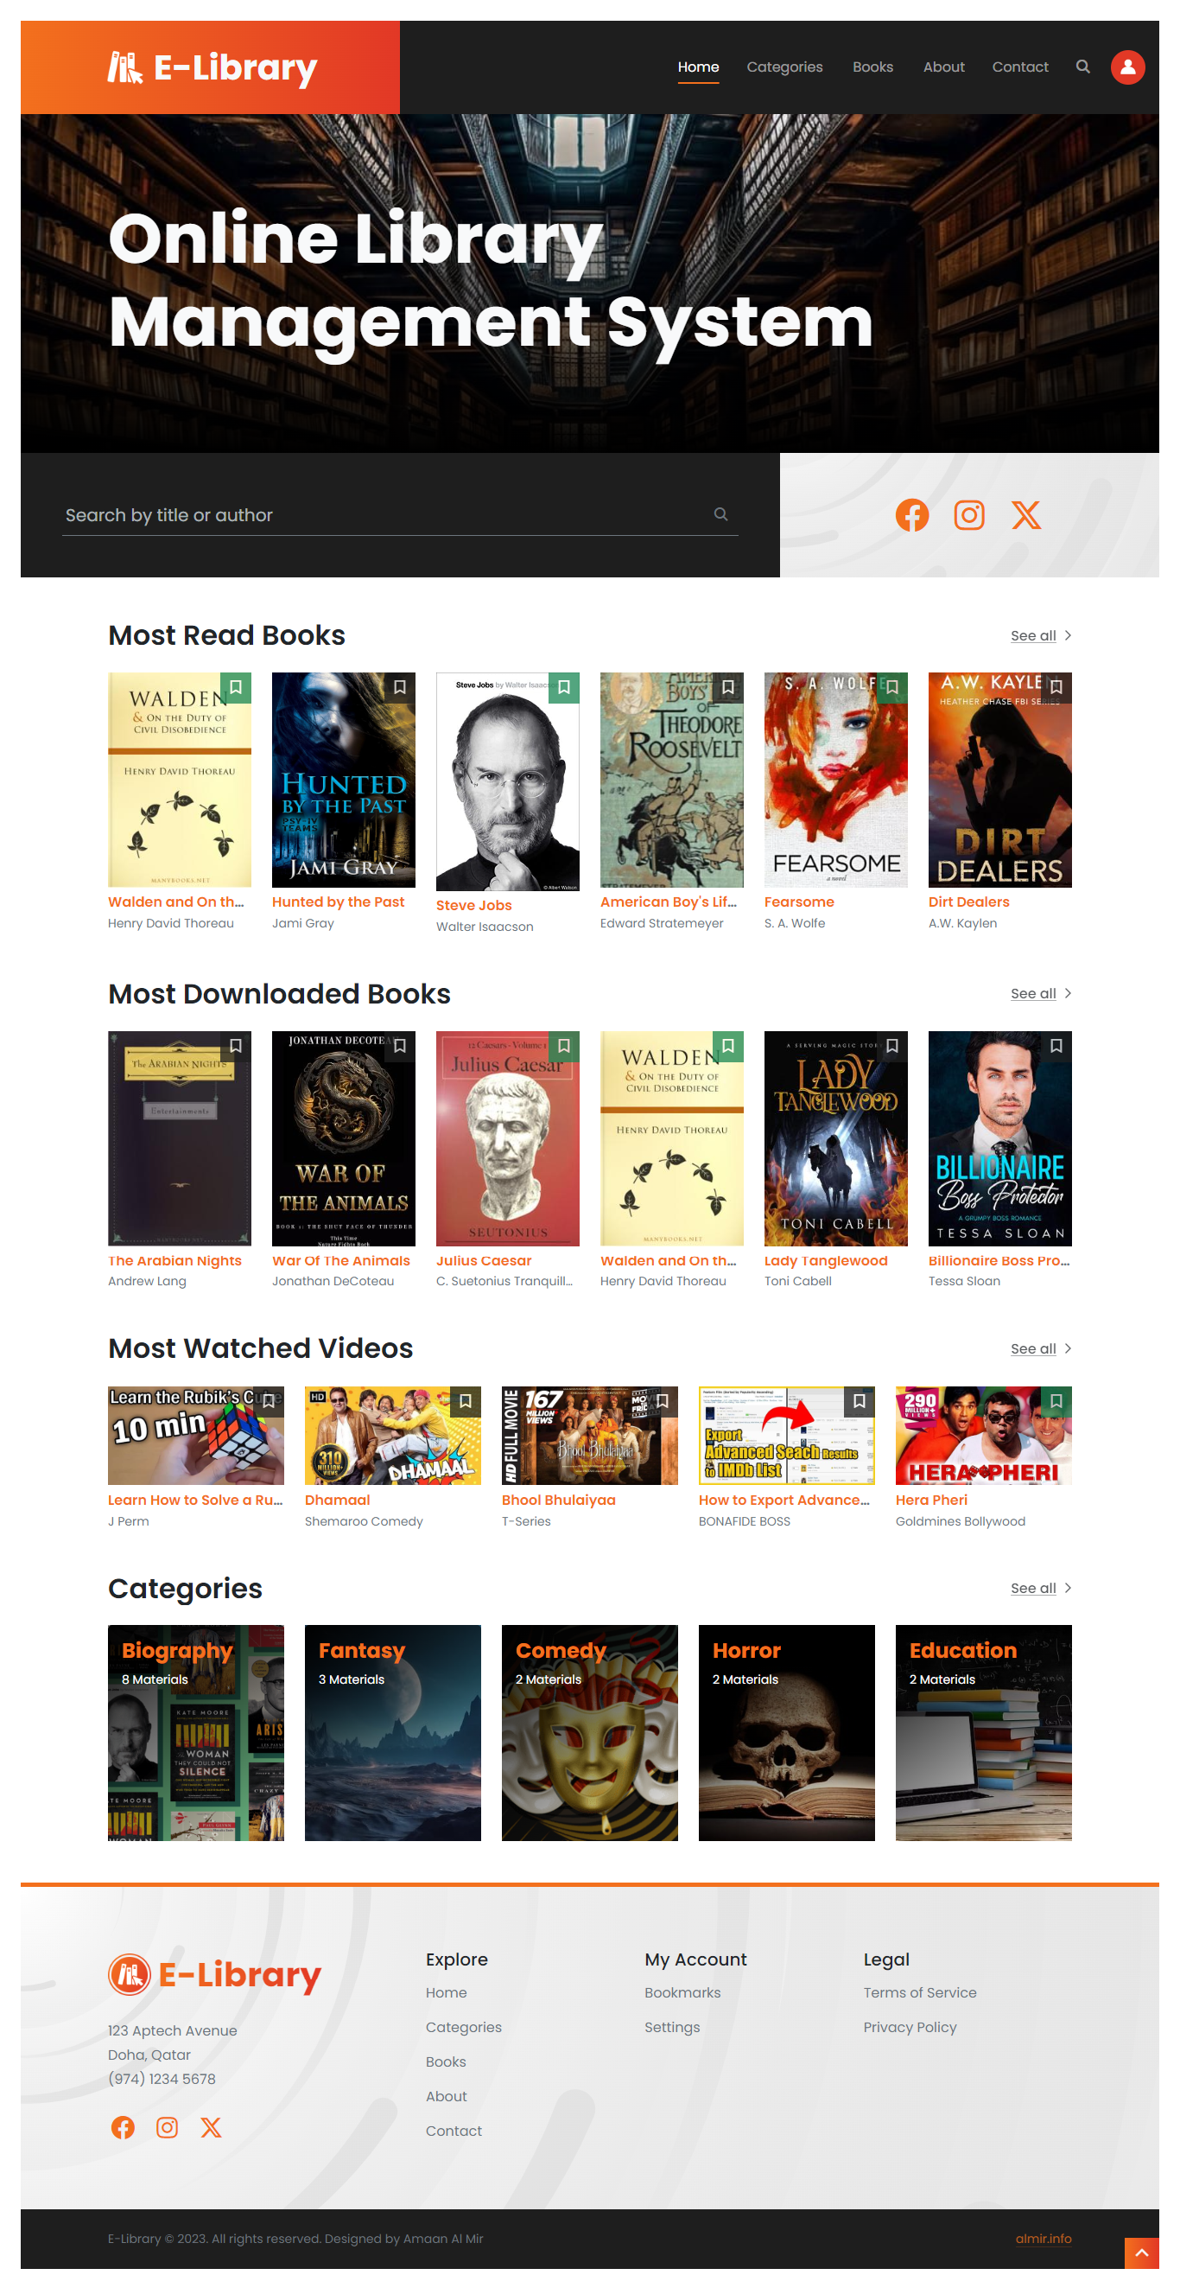

## Categories

On this page you can find a list of categories available.

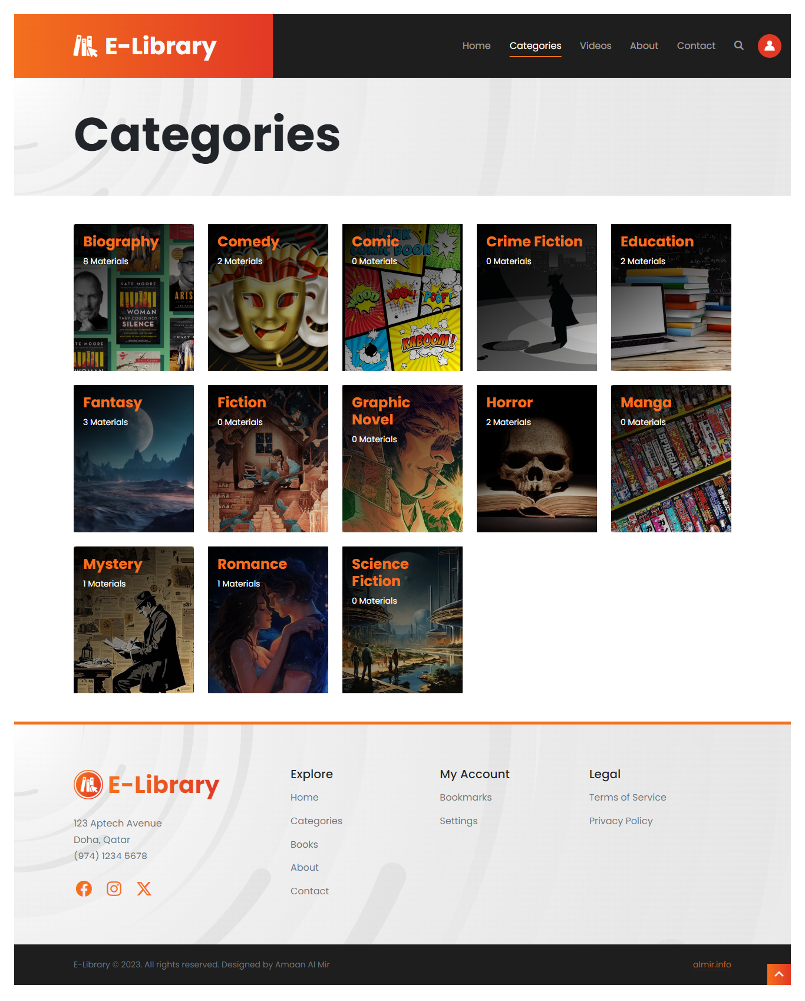

## Books & Videos

On this page you can find list of books and videos.

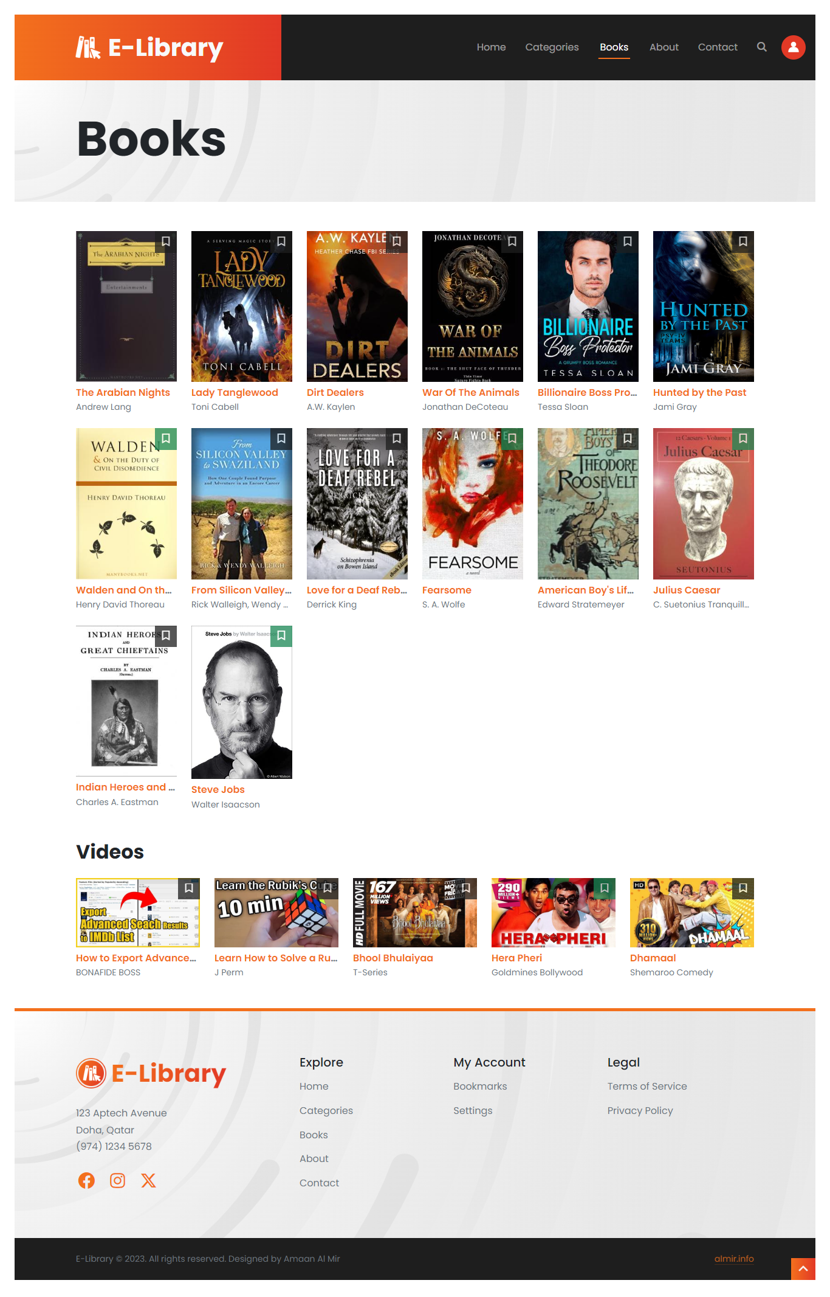

## Search

You can open the search menu from any page click on the search button given in the top navigation bar.

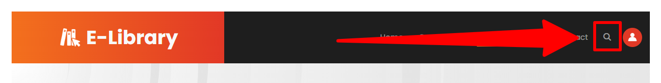

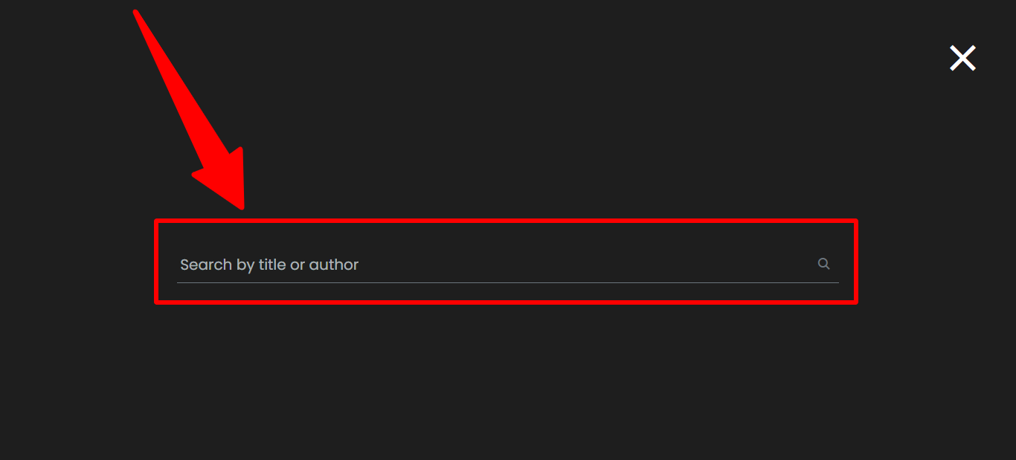

You can search for a book or a video by its title or author.

## Book Details

You can view any book or video details by clicking on it.

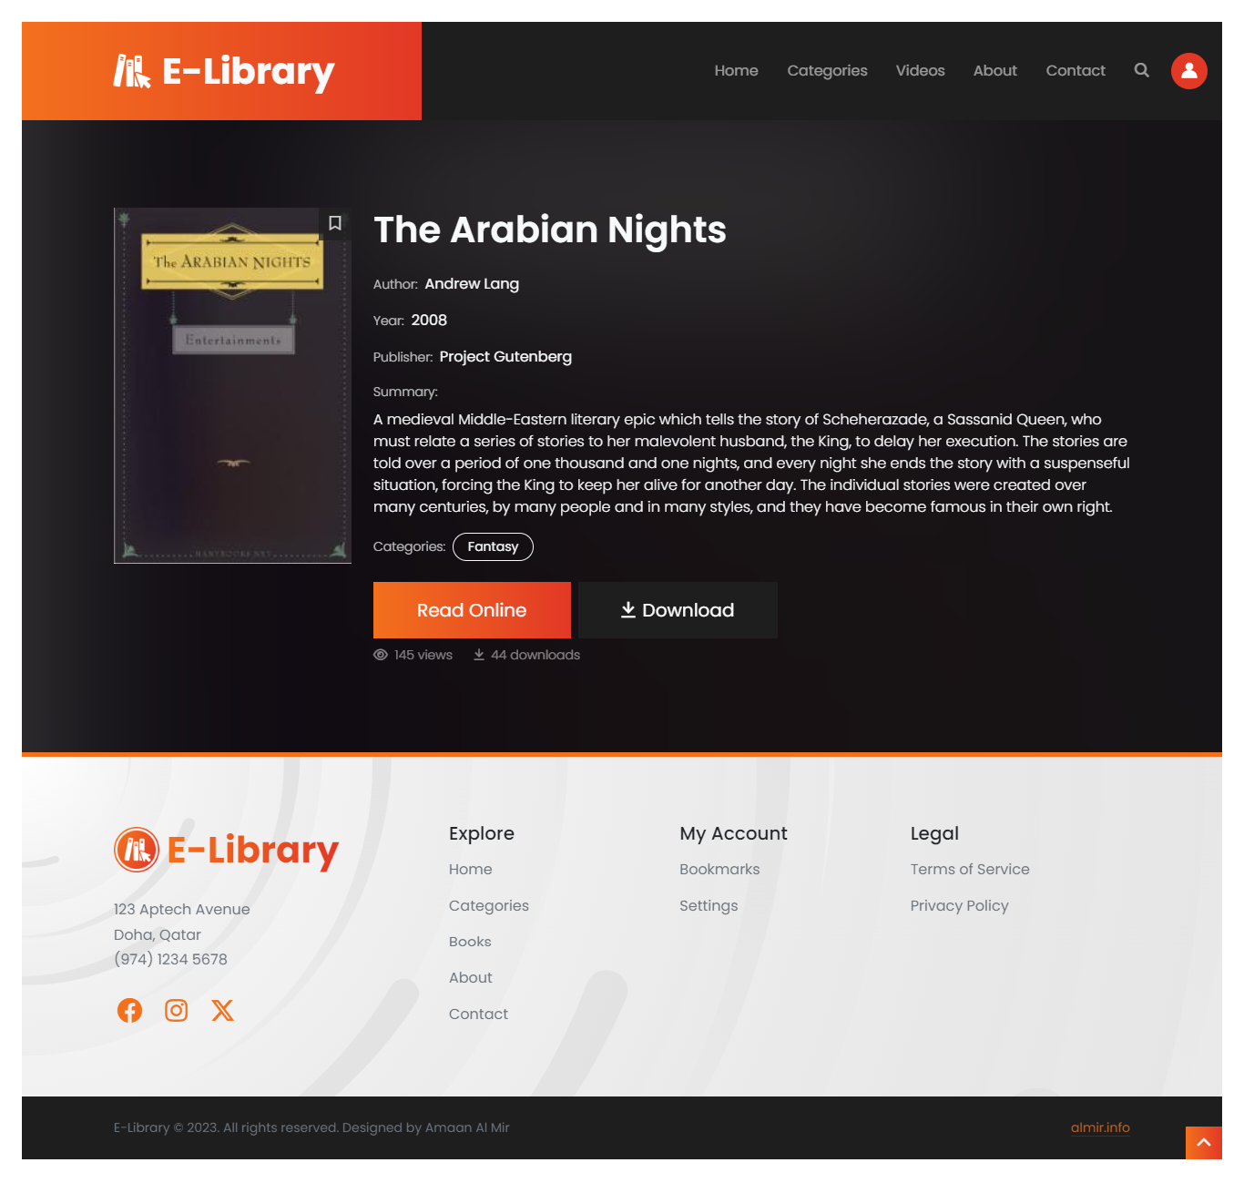

Note: Not all books can be downloaded.

## Read a Book Online

Non-logged in users will be asked to login before they can read the book online.

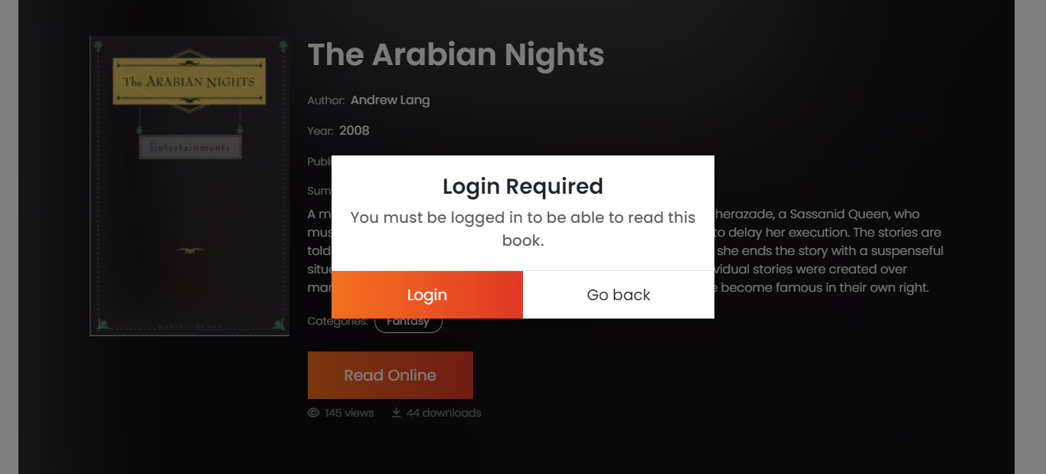

Logged-in users can click on the read button the read the book.

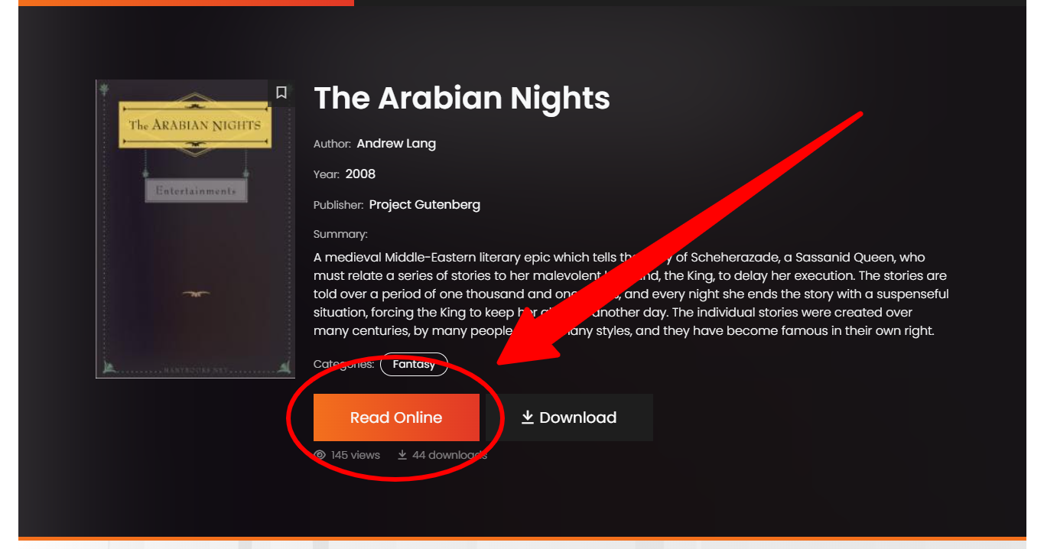

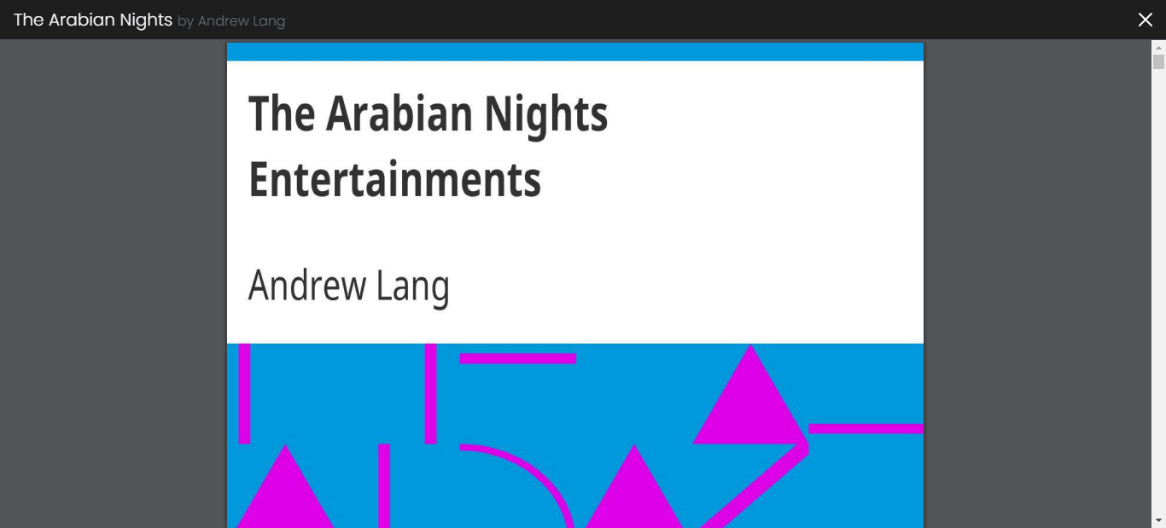

Some books are also allowed to be downloaded by the librarian.

## About & Contact pages

On these pages, you can find general information about the library like timings, no. of books available online, contact information, and location.

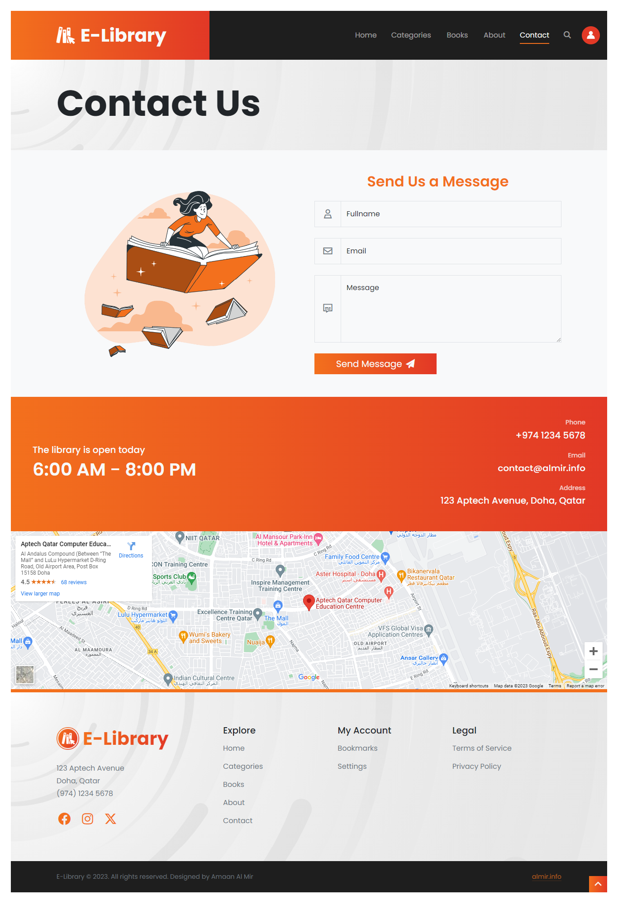

You can also use the contact form to send message to the librarian.

## User Account

On this page, you can update your account details like avatar, email and password.

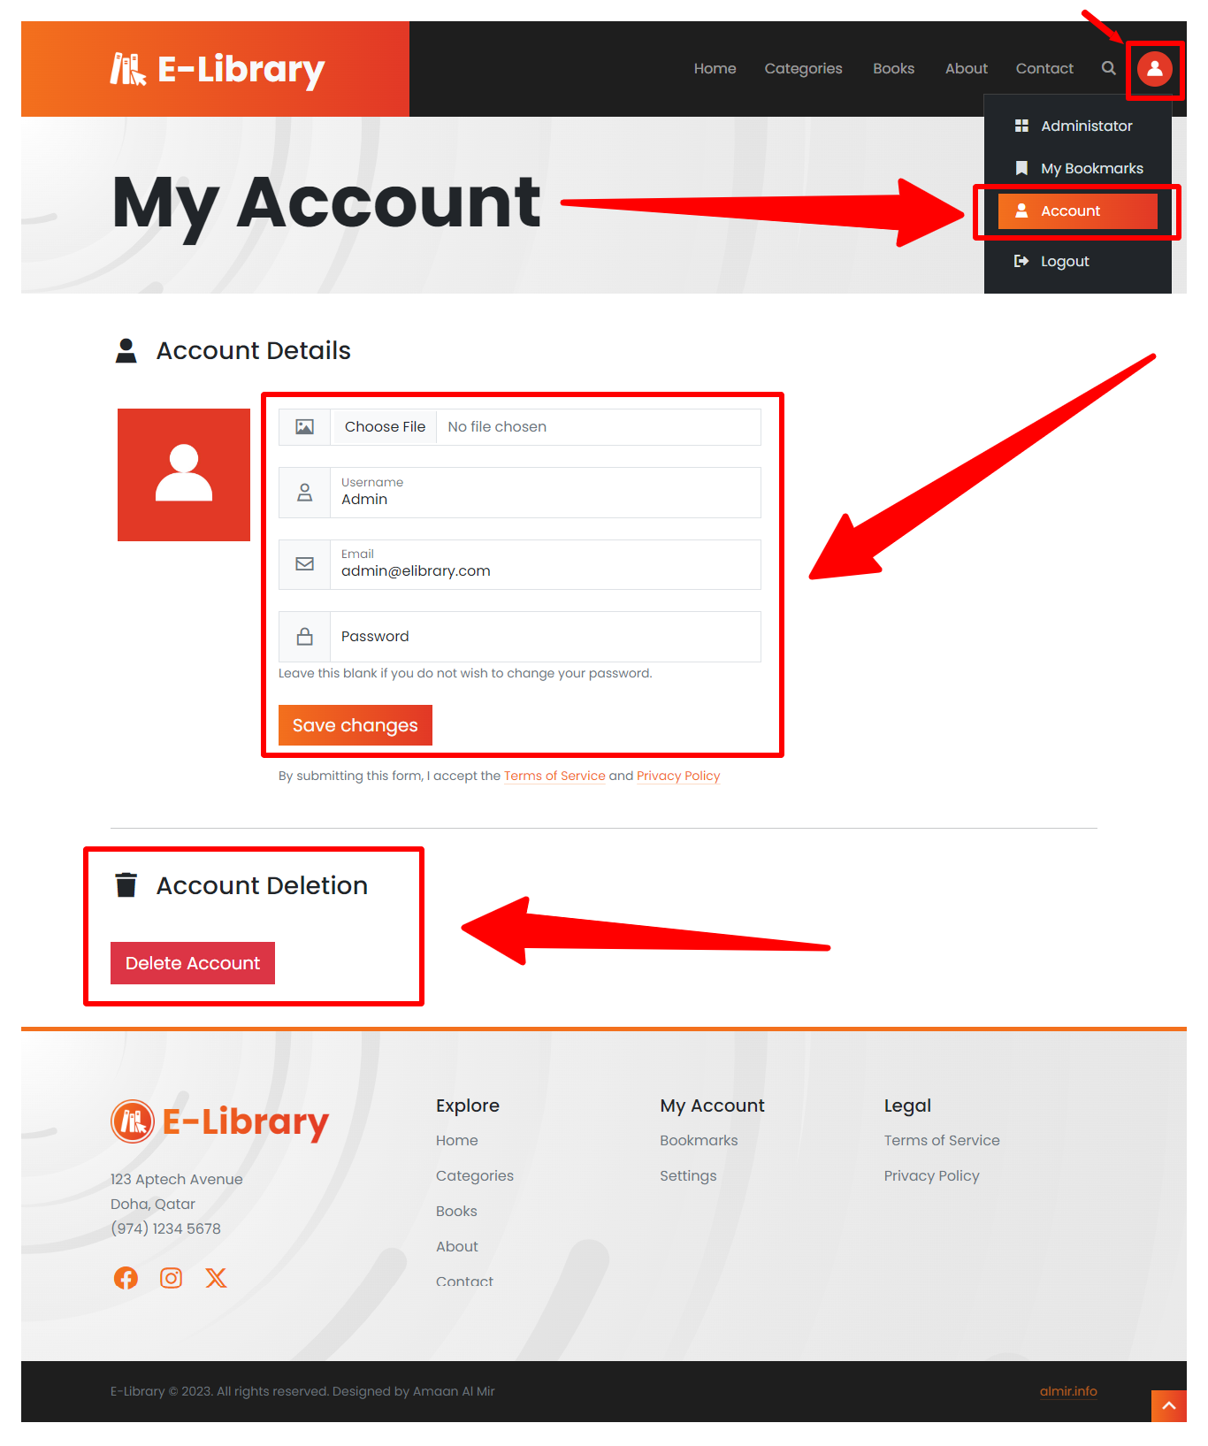

You also have the option to delete your account.

## Website Administration

The website offers administration services that can the librarian manage the E-Library’s categories, books, and users.

To go to this Admin dashboard, click on the button shown in the picture below:

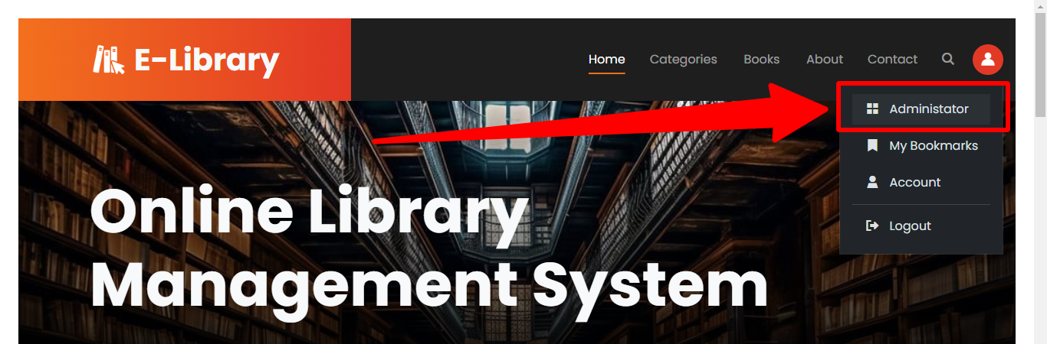

Users without admin permission will be denied access to the website administration pages.

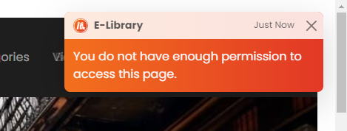

### Dashboard

On this page, admin can see an overview of categories, books, and users in the online database.

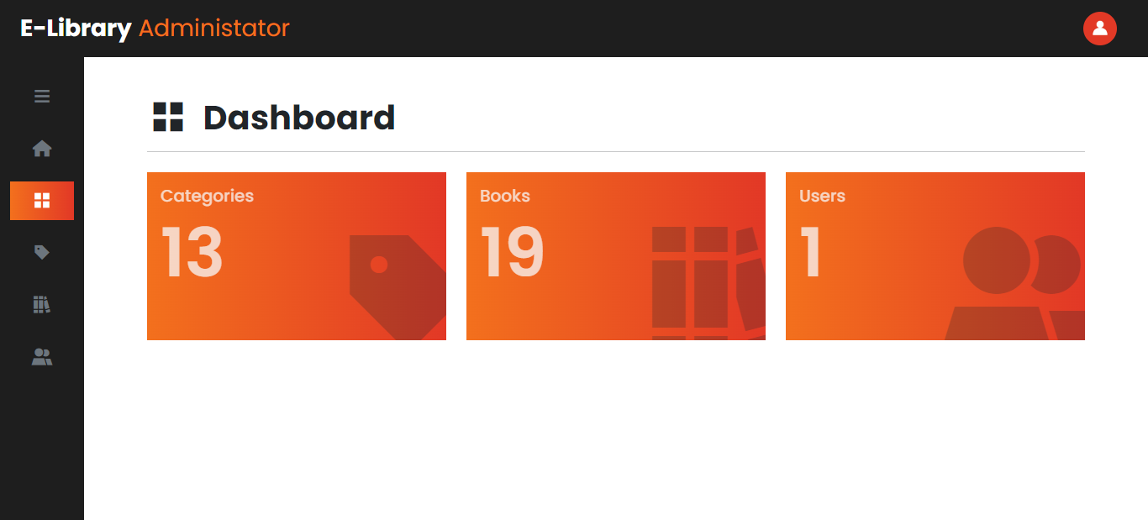

You can use side column to navigate through admin pages.

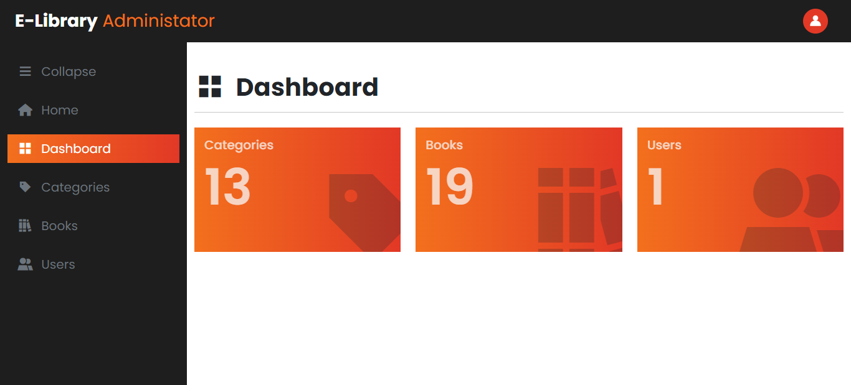

### Manage Categories

On this page, admin can create a new category or update and delete existing categories.

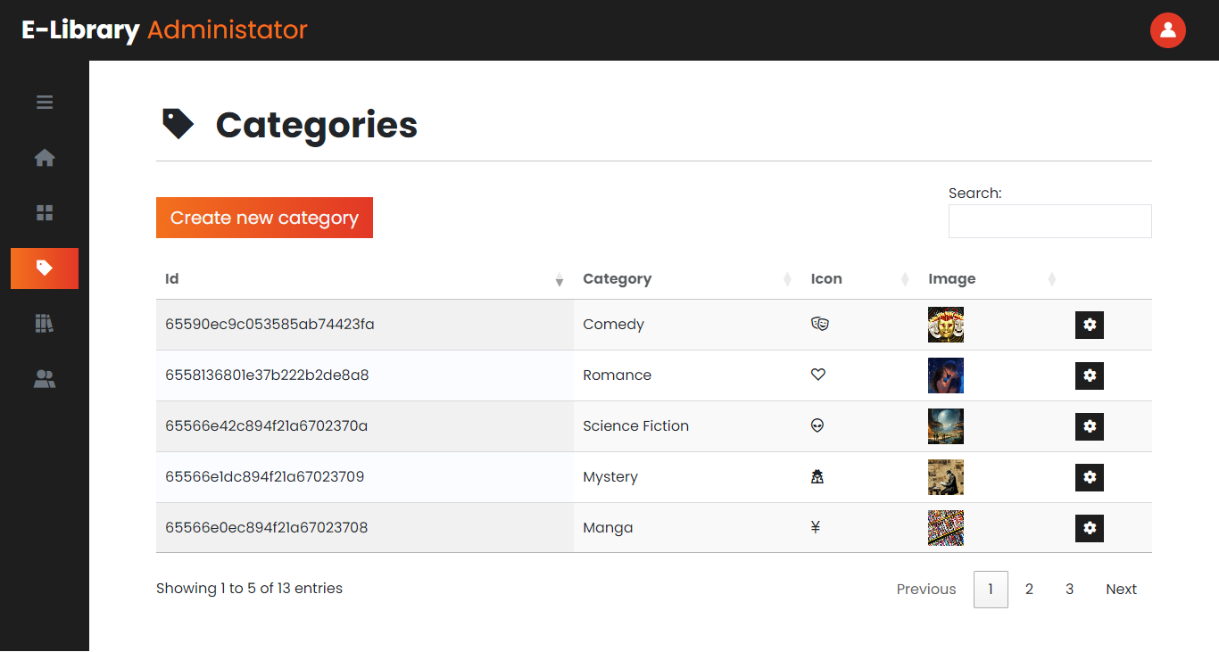

#### Create New Category

To create a new category, click on the “Create new category” button.

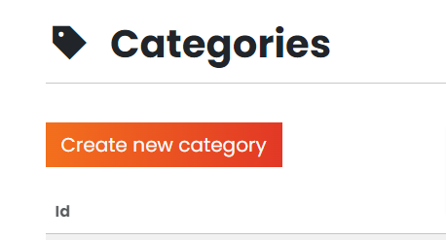

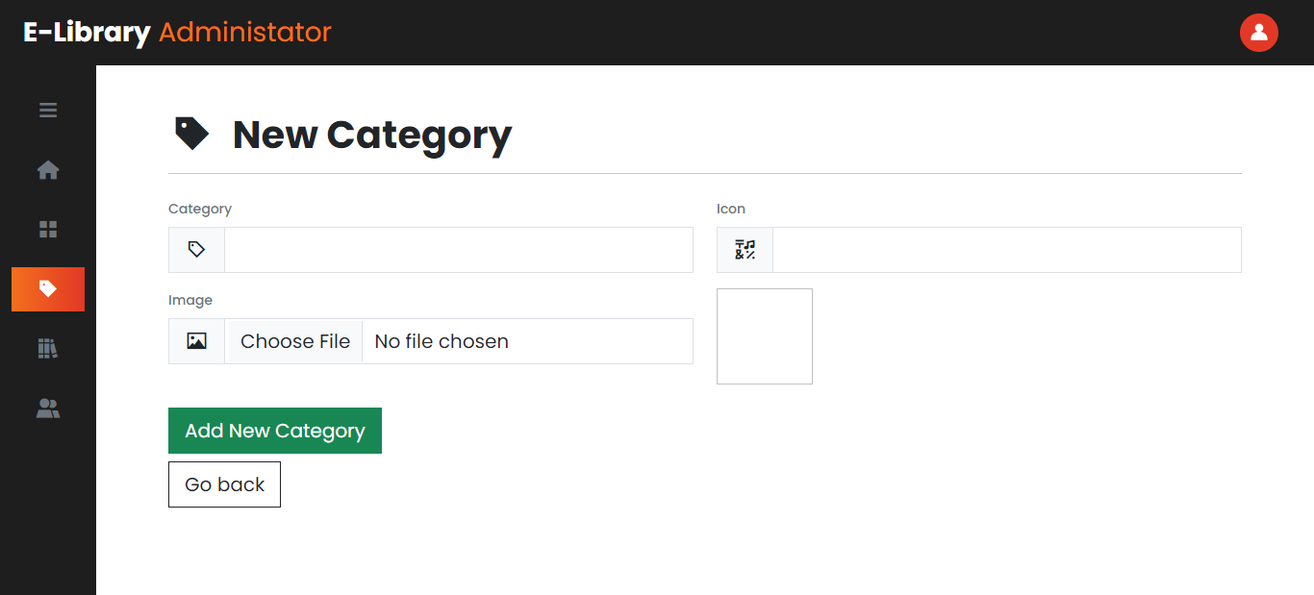

Fill the necessary details like category title, icon and an image, then click on the add button to add the category to the database.

#### Update/Delete a Category

To update or delete a category, click the gear icon next to the category to open the edit page where you can edit or delete it.

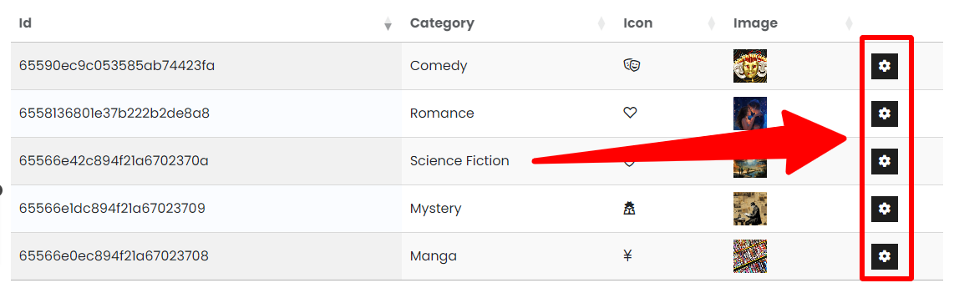

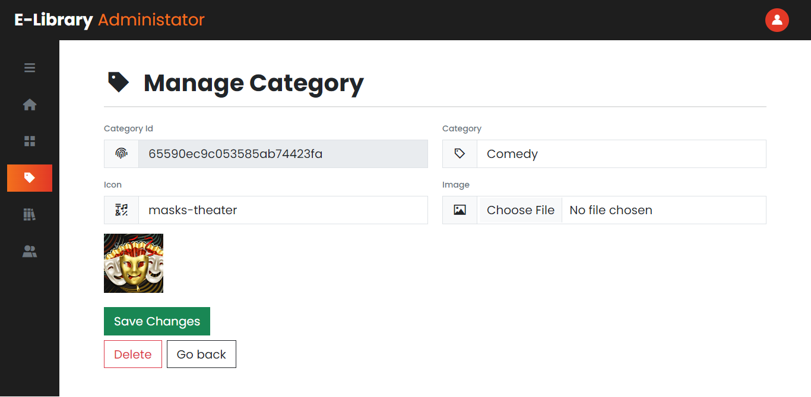

Make changes you want to make and click the green button to save them.

To delete it, click the delete button next to it.

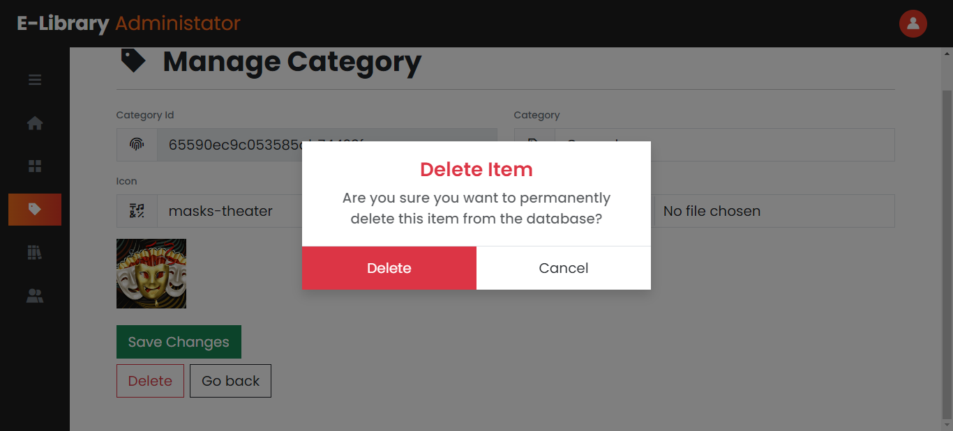

Then confirm the deletion by clicking on the delete again.

### Managing Books and Videos

This is also similar to categories, only data is different.

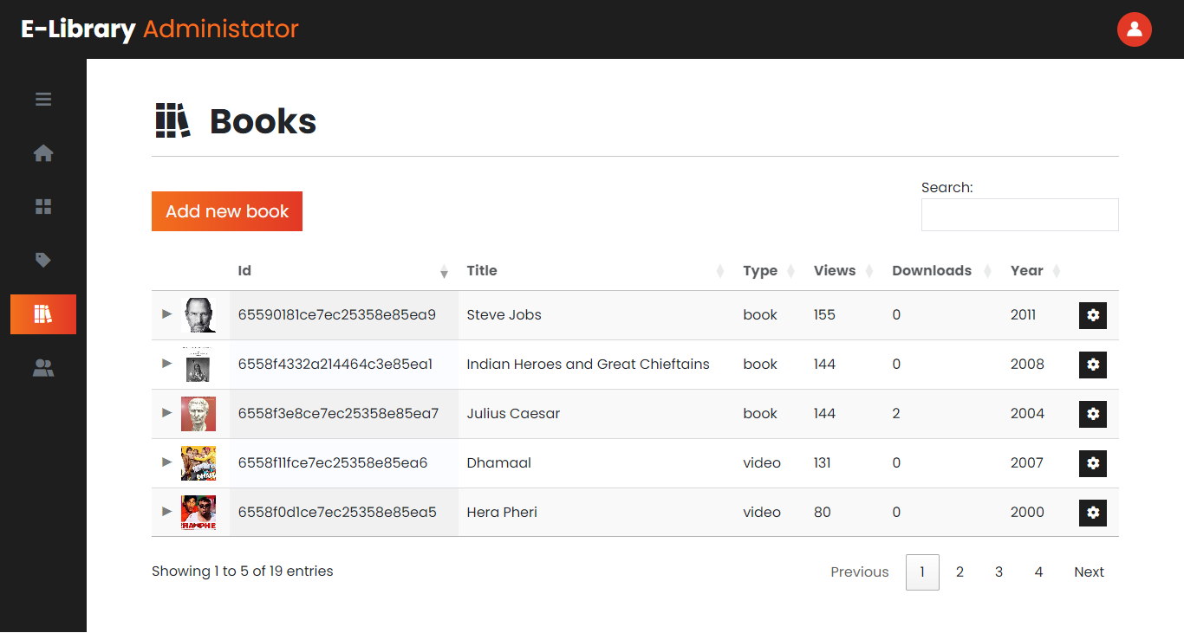

#### Add New Book or Video

Select book or video by changing type.

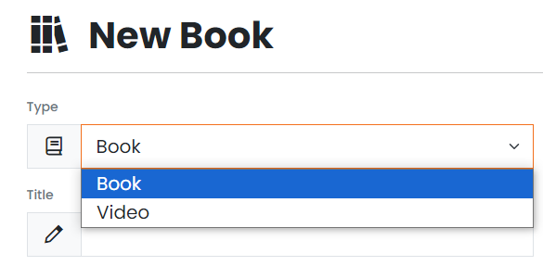

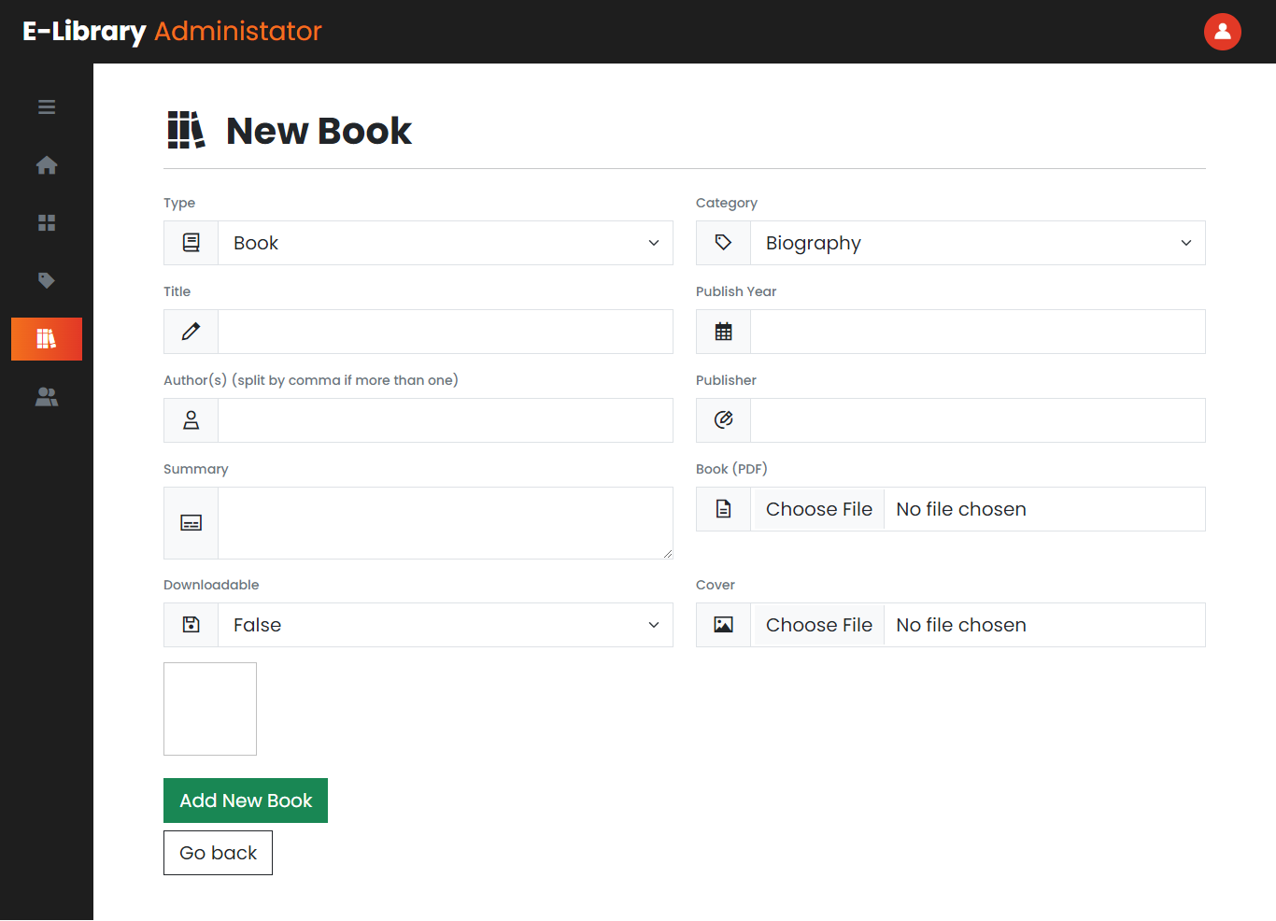

Fill up the rest of the details to add a book or a video.

Note: Only PDFs are supported for books. And for videos, enter an embed YouTube URL.

Example of an embedded YouTube URL:

<https://www.youtube.com/embed/jzYxbnHHhY4>

#### Update/Delete a Book or Video

This is similar to updating or deleting a category.

### Managing Users

Managing users is also similar to managing categories and books.

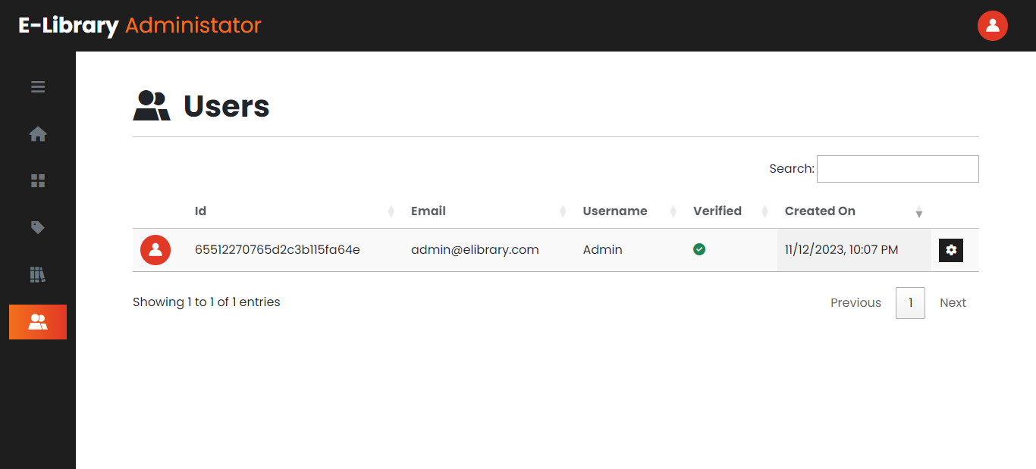

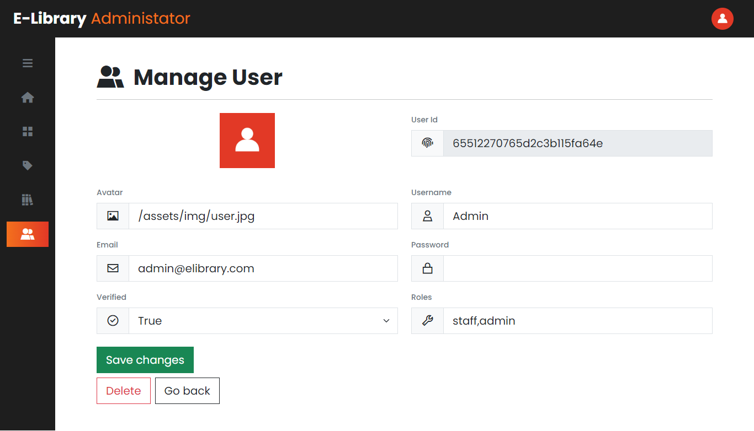

## Mobile & Tablet View

The website responsive and mobile-friendly.

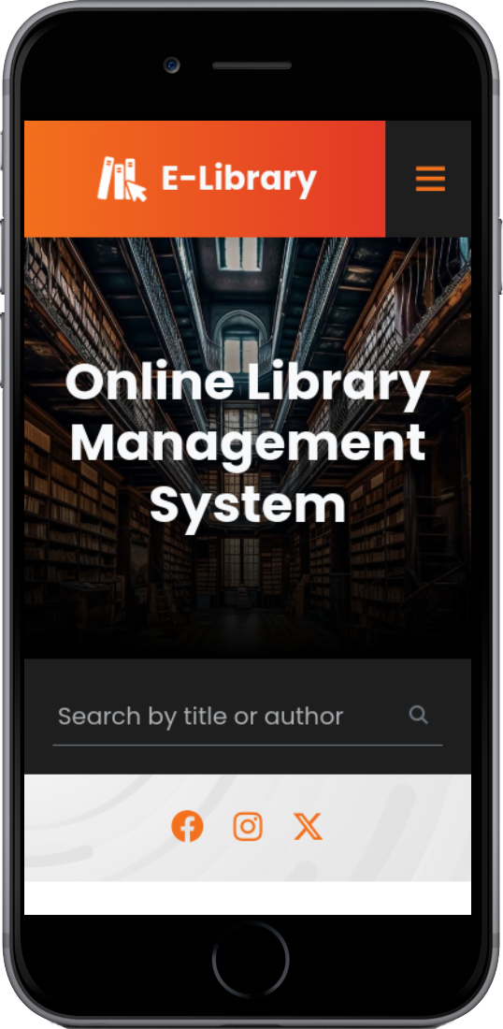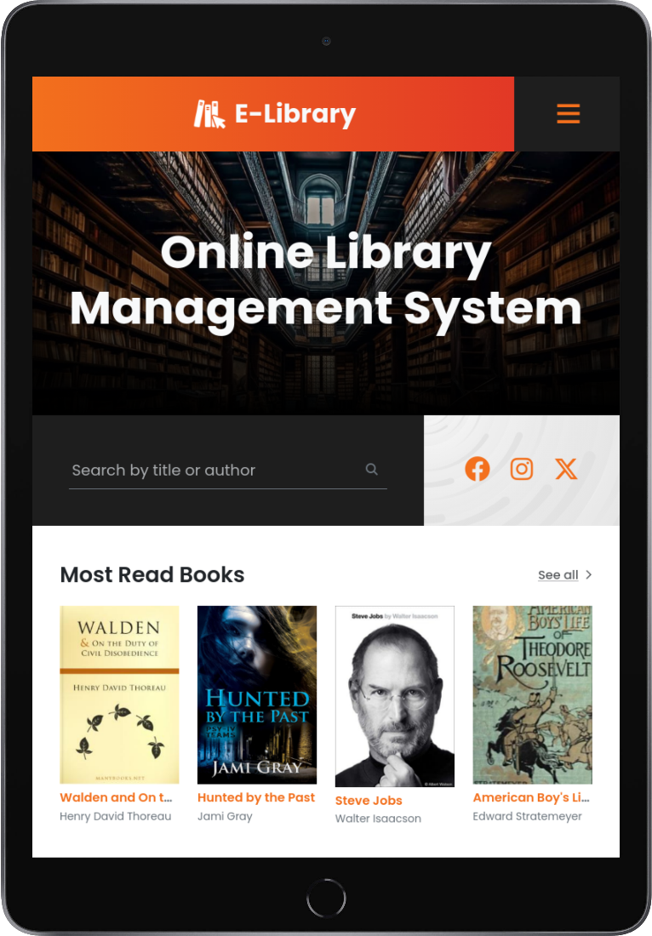

You can open the nav by clicking on the button shown below:



# Developer Guide

## Technology Stack

Frontend:

* HTML
* CSS
* JavaScript
* jQuery v3.7.1
* Bootstrap v5.3.1
* Font Awesome v6.4.2

Backend:

* Python v3.11.6
* Flask v3.0.0
* Flask-PyMongo v2.3.0
* Flask-WTF v1.2.1
* Email-Validator v2.1.0
* Flask-Mail v0.9.1
* Requests v2.31.0
* Filestack-Python v3.5.0

Database:

* MongoDB

Web Services:

* ImgBB – Image storage
  + Used to store book covers, video thumbnails, and user avatars
* Filestack – File Storage
  + Used to store books
* YouTube – Video Storage
  + Used to store videos
* Google SMTP (Mail) Server
  + Used to send email address verification and password recovery emails

## How To Run the Application?

### Prerequisites

Make sure you have the following downloaded and installed in your system:

* Python 3.9 - 3.11
* If you didn’t get the project files along with this documentation, you can download them from:

<https://github.com/BonaFideBOSS/E-Library>

* Request the config.py file from me which contains all the secrets like database connection string and APIs

### Method 1

Simple double-click on the start_app.bat file to start the application. It will take a few seconds to start up in the first run.

Note: If this is your time, it will take much longer to initialize and start up the application.

### Method 2

If method 1 fails to start the application, open CMD inside the project directory and run the following commands:

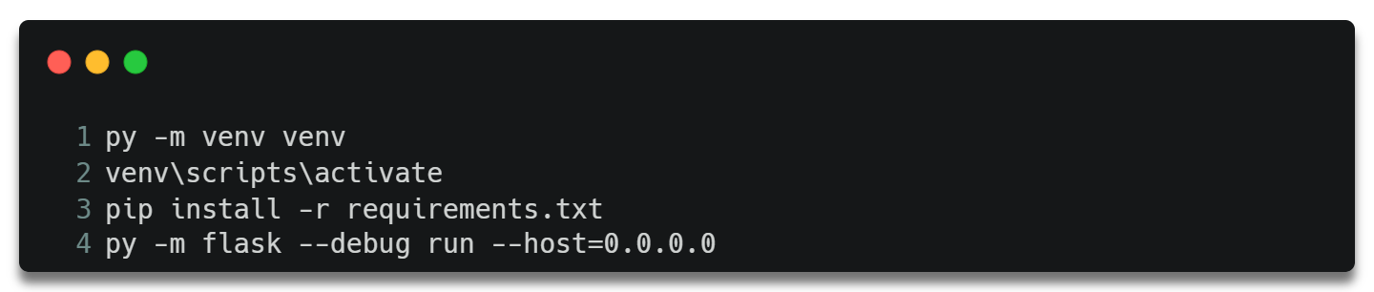

Note: Each command should be executed separately in a new line.

If successful, you should see something like this on your screen:

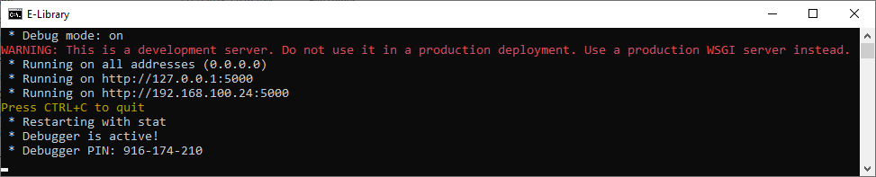

Then, simply open a browser and go the address shown in your terminal.

## Source Code

### Website Structure

|  |  |  |  |  |
| --- | --- | --- | --- | --- |
| website | | app.py | config.py | |
|  | assets  This folder contains CSS, JavaScript, and image files |  | |  |
|  | views  This folder contains HTML files |
|  | __init__.py |
|  | admin.py |
|  | admin_forms.py |
|  | auth.py |
|  | forms.py |
|  | helpers.py |
|  | mailer.py |
|  | user.py |
|  | views.py |

Each of these files and their purposes are explained below.

### Backend

#### config.py

This file contains all the secrets of the application like database connection string, Mail credentials, and APIs. It also contains general information about the website like website name, icon, logo, and description.

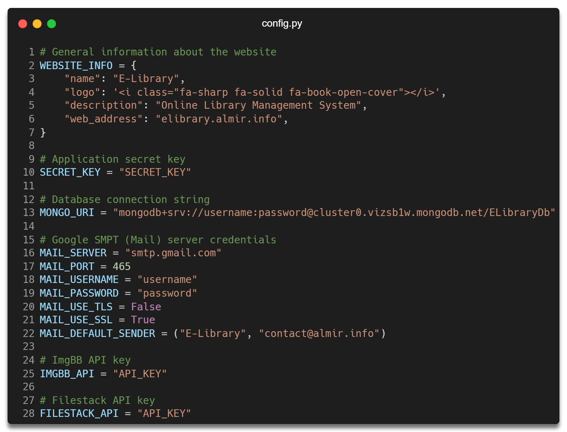

#### app.py

This is the main file of the entire application that is used to run the application.

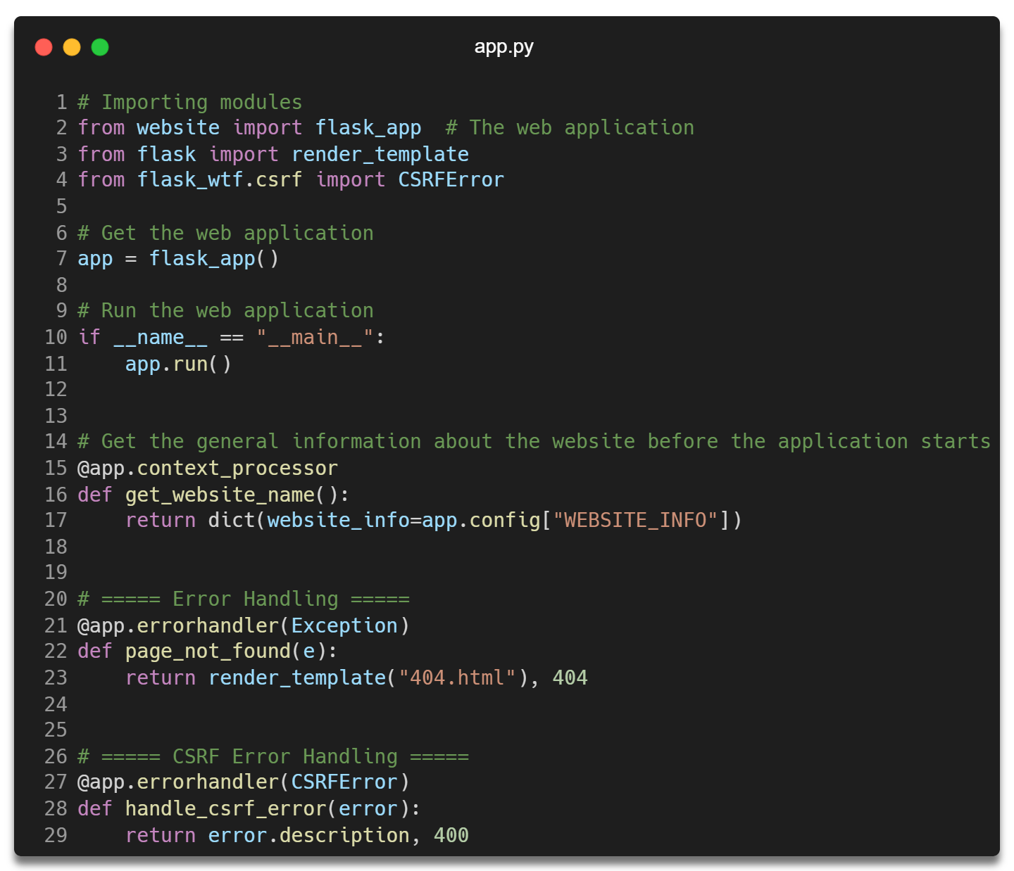

#### __init__.py

This file is used to initialize the web application and turn the website folder into a python package.

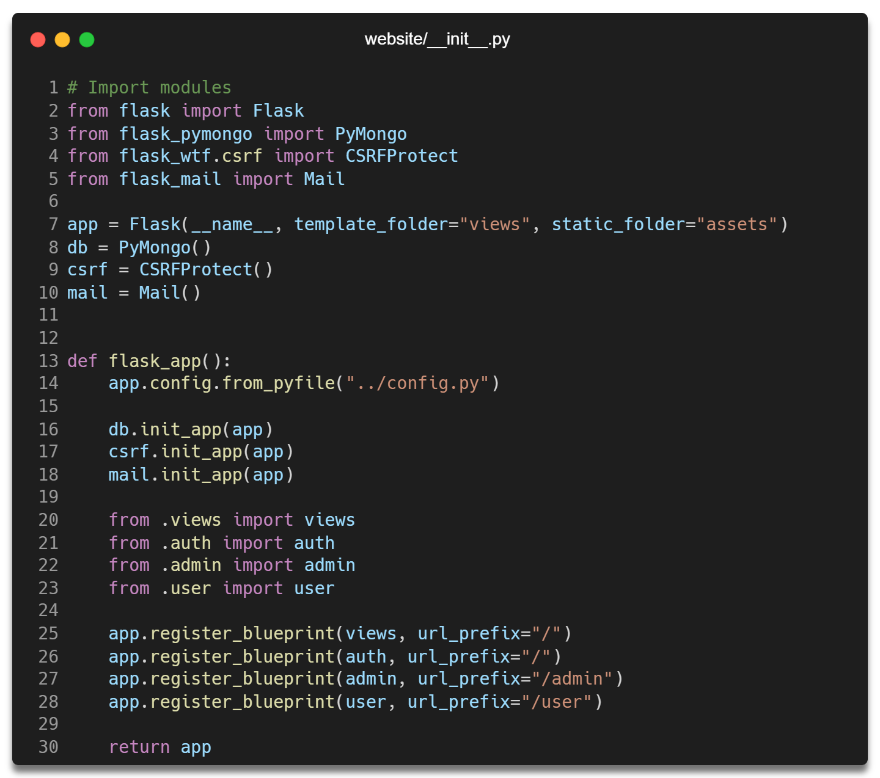

#### admin_forms.py

This file is used to define structure of the forms used in the admin dashboard.

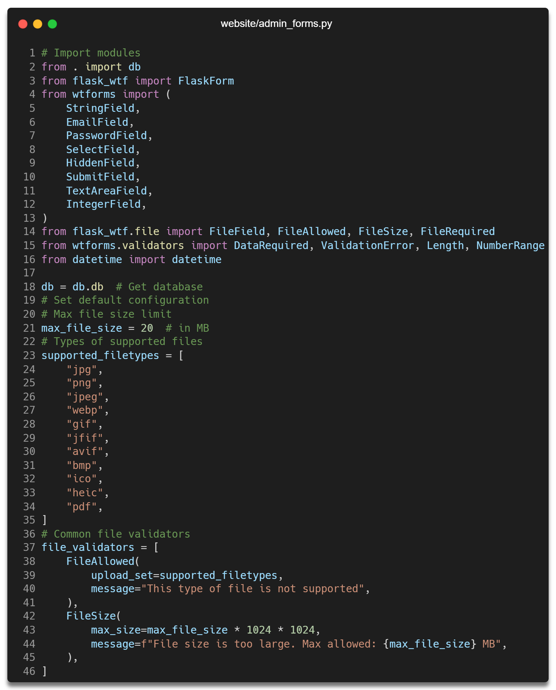

This class helps to validate and render forms when creating or updating a category.

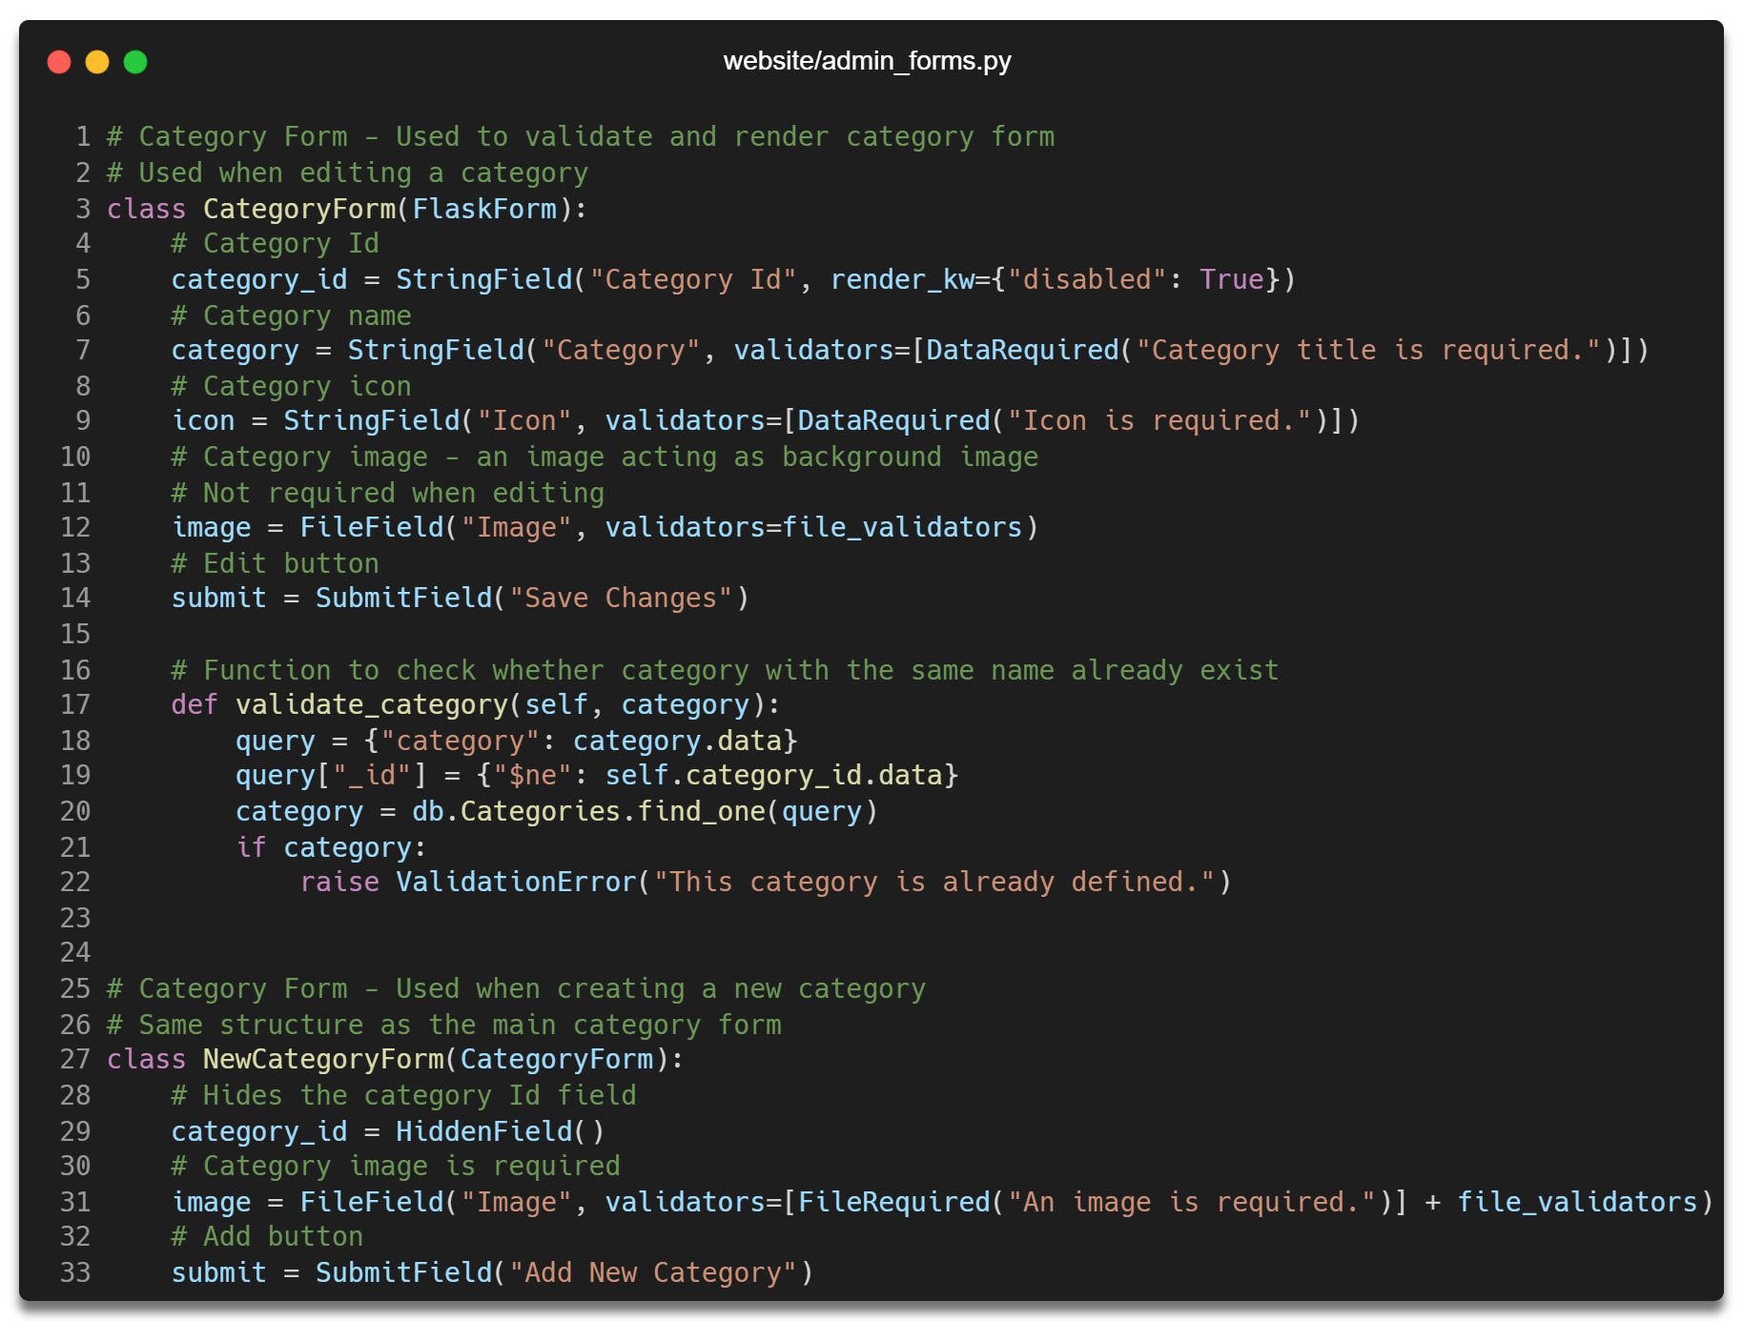

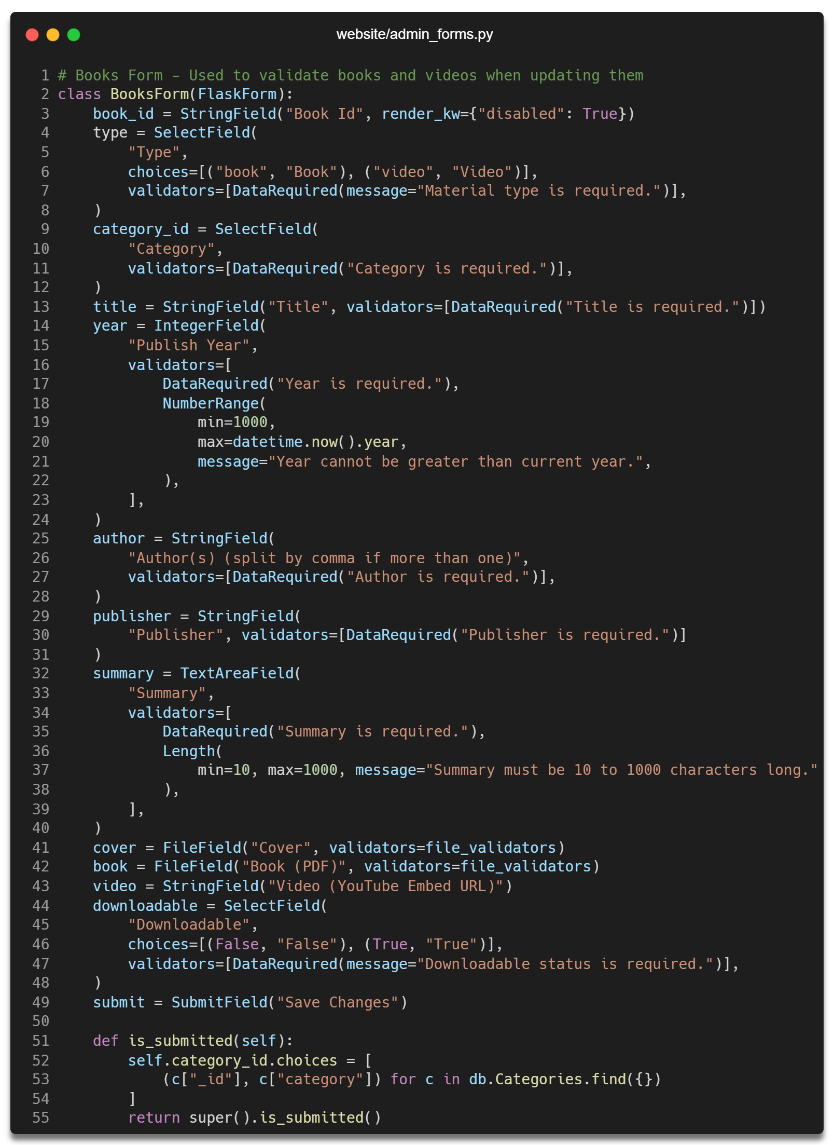

# References